CS412 - CS512

Machine Learning

Fall 2017

Homework 1

40pts - Due Oct 6 @ 10pm

(Late accepted until two days after due date, Oct 8@ 10pm, with 5pts off each late day)

Task: For this homework, you will use a decision tree classifier for a digit recognition problem, which we will use throughout the class. The aim of this homework is to get started with a simple machine learning tool/library (WEKA); learn to interpret the results; and get familiar with a problem that will be our test bed.

Data: MNIST dataset is a well-known dataset from a real-life problem. It consists of images of handwritten digits with the corresponding labels (10 classes). The images contain grey levels and they are centered in a 28x28 image. Samples of these images are given below:

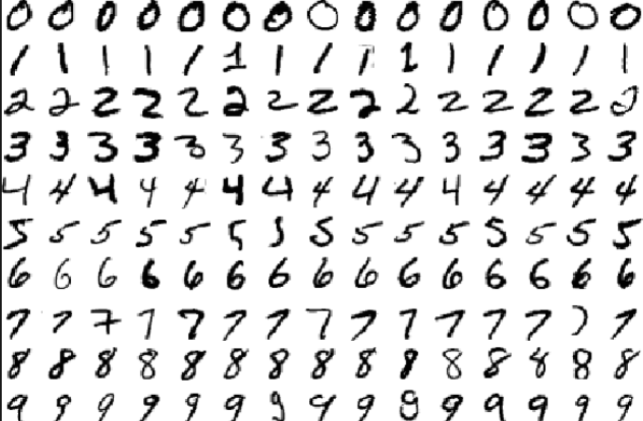

While the original MNIST dataset has a training set of 60,000 examples, and a test set of 10,000 examples,
we took the official test set and partitioned it into a new training set (80% of the original test data) and a new test set (the rest) so as to reduce the amount of data load on your computers. Public reported accuracies should still apply for the most part, if you are interested in checking them out. More information about MNIST database can be found at http://yann.lecun.com/exdb/mnist/

The given train and test data consists of two separate arff files as train and test sets that can be found under http://people.sabanciuniv.edu/berrin/cs512/hws/hw1/
folder (our web page). The features are pixel values (28x28 = 784) in 0-255 range corresponding shades of gray.

Note: If you have installed WEKA, this homework can be done in 20-30 minutes. If not, please follow weka-tutorial slides under Lectures.

DETAILS

You are supposed to train two classifiers (see below) and classify the test data into one of the 10 classes; and interpret results.

- 10pts - First choose ZeroR as classifier and use test set (supplied) as test. Explain the resulting accuracy and confusion matrix in 1-2 lines each, using correct/precise terminology. E.g. we don’t just say “performance is good”, we talk about error or accuracy as … and to make sure we are understood clearly, in scientific writing, when something may be misunderstood, we add a redundant explanation like: “in other words, …”

Note: ZeroR is the classifier works by choosing the most likely class label, regardless of the input. Its accuracy is called the base error rate. So it is quite dumb, but it gives a baseline and a minimum expectation for any particular problem.

5pt - Accuracy:

……………………………………………………………………………………………………………………………………………………………………..

……………………………………………………………………………………………………………………………………………………………………..

5pts - Confusion matrix: How is each sample classified? What is the assigned label?

……………………………………………………………………………………………………………………………………………………………………..

- 20pts – Now try the decision tree classifier J48 under trees, with the DEFAULT parameters.

- 5pt - What is the accuracy (correct classification rate) with 10-fold cross validation? …………….……%
- 5pt - What is the accuracy (correct classification rate) with supplied test set? ………………………..……%
- 10pt - Which accuracy (test or cross-val.) do you expect for this problem to reflect the generalization accuracy better? Why? Explain your reasoning in one line.

……………………………………………………………………………………………………………………………………………………………………..

……………………………………………………………………………………………………………………………………………………………………..
- 10pts – Experiment and report here whether it helps to use some form of pruning or stopping early in growing the tree. Just state VERY briefly what you have tried and if it helped (your grade will not be based on this new accuracy, so don’t spend more than 10-15 minutes on this part. If you just try a few things, this is sufficient for full points. The aim is for you to look up some parameters and try different things and observe results ).

