Demonstration of Polynomial Curve Fitting

>> myfunc(X1,y1)

X =

1 2
1 4
1 6
1 8

y =

4
7
10
13

w =

1.0000
1.5000

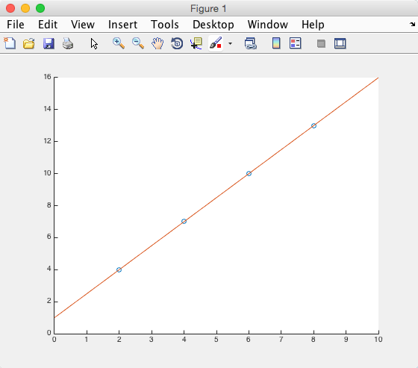

If I did not allow for y-intercept:

>> myfunc(X1,y1)

X =

2
4
6
8

w =

1.6667

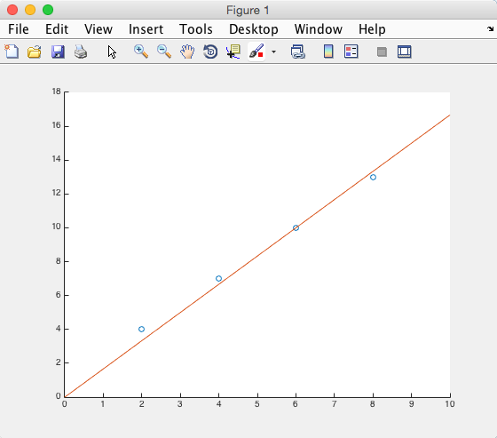

If the mapping is quadratic:

>> myfunc(X1,y2)

X =

1 2
1 4
1 6
1 8

y =

6
18
38
66

w =

-18.0000
10.0000

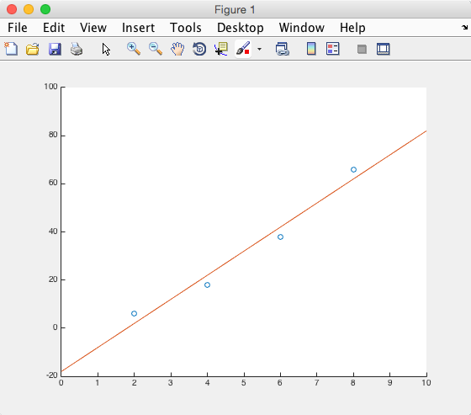

Worse when range is larger:

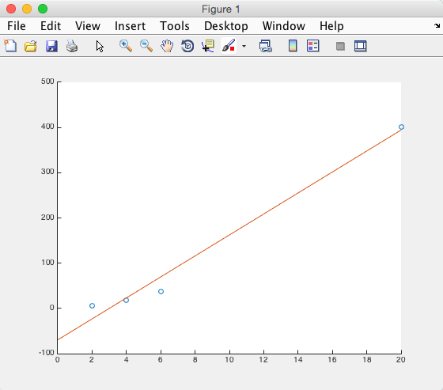

If we add higher order components:

>> myfunc(X2,y2)

X =

1 2 4
1 4 16
1 6 36
1 8 64

y =

6
18
38
66

w =

2.0000
-0.0000
1.0000

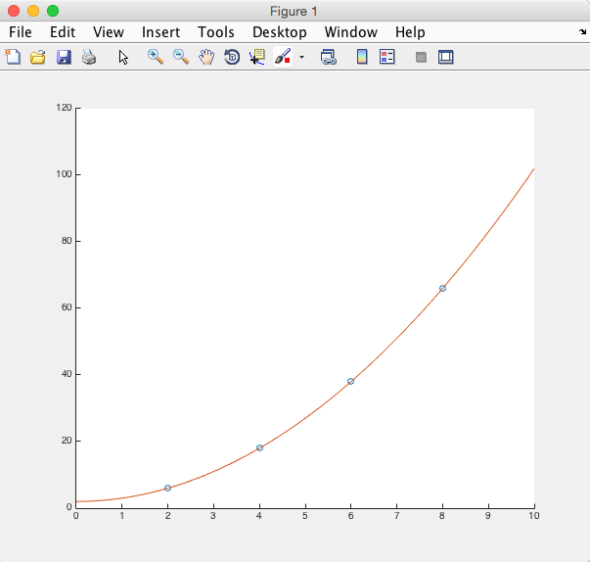

x=[2;4;6;8;10];
y=[5;17;37;65;101]

p=polyfit(x,y,1)

xr= 0:1:20;
yr=polyval(p,xr);
plot(x,y,'o',xr,yr);

p2=polyfit(x,y,2)
yr=polyval(p2,xr);
plot(x,y,'o',xr,yr);

