CS 412/512 Machine Learning
Midterm 2

99pt

Dec. 12, 2017

- Allocated space should be enough for your answer. Give brief & clear explanations for full credits.
- Please write legibly and circle your final answer.
- No questions please. You may make additional assumptions if you think it is necessary, but if you do so, clearly state them.
- No Internet, no cell phones!

Question |  | Score | Max Score
1 | Multivariate Normal |  | 15
2 | Neural Networks |  | 30
3 | Classifier Combination |  | 15
4 | SVM |  | 15
5 | General |  | 25
TOTAL |  |  | 100

Reminders:

Sigmoid(x) = 1/(1+e^{-x})

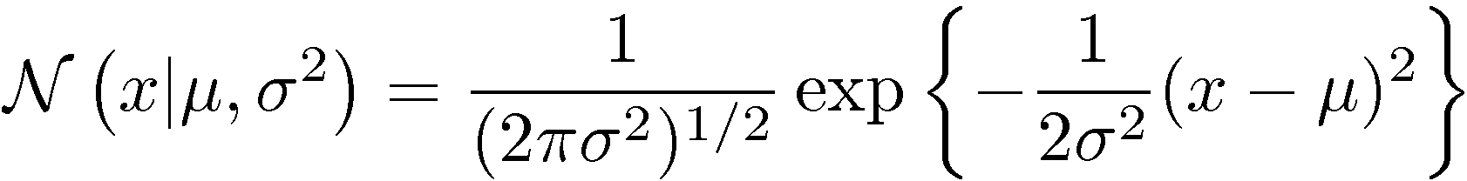

1) 15pt – Multivariate Normal – Bayes Classifier

a) 4pts – Answer as True/False, as appropriate. 2pt each. -1 each false guess for T/F questions.

- T/F The correlation between two random variables x, y is symmetric (i.e.. ρ_{xy} = ρ_{yx}).

- T/F The maximum likelihood estimate μ_{ML} of the mean μ of a Normal distribution is unbiased.

6 - Fill-in-the-blank:

- 3pts - What is the correlation between the two random variables for the given $covariance matrix$
$\sum{ =\left[\begin{aligned} 4 -6 \\ -6 9\end{aligned}\right]}$. Answer: .........................

- 3pts - “The maximum likelihood estimate σ_{ML} of the standard deviation σ of a Normal distribution is biased because

................................... ≠....................................”. (Be careful to details)

c) 4pt – Give suitable covariance matrices for the two Normal distributions that are shown with their equal density contours. No need to worry about which variation may be bigger.

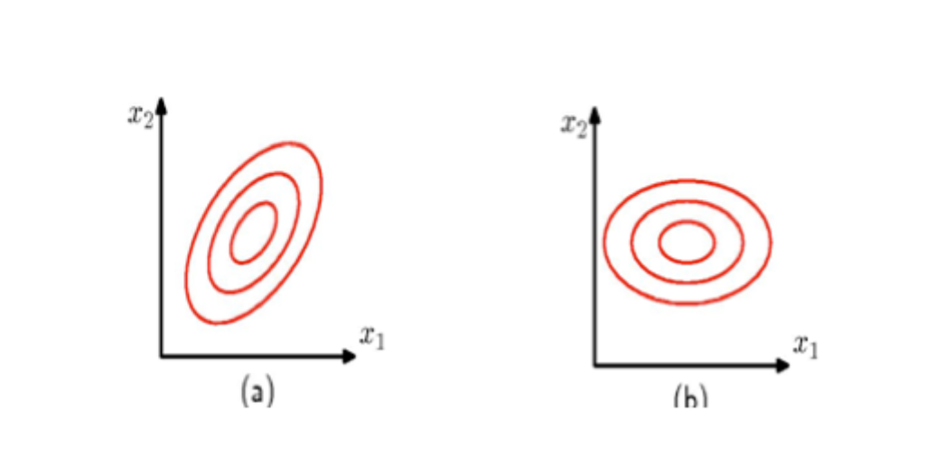

Σ = Σ=

2) 30pt – Neural Networks

a) 6pt –You are looking for the minima of the following function f(x,y) = y² – 5x + 2xy. Starting with the point x= 1 and y= 1, trace one step of the backpropagation algorithm by computing the derivative and finding the next value for the (x,y), using a step size of 0.1. Show your work.

Gradient =

Next values for (x,y) = .........................

b) 8pt – We are given the following binary classification problem, where + is the positive class and – is the negative class.

+ +
-
-
-
A
B
+
-
-
-
-

80

20
i) 4pt –What is the weight vectors w_{A} and w_{B}, corresponding to the following two decision boundaries A and B, respectively?
Draw them on the figure as well.

w_{A} = w_{B} =

ii) 4pts – Give the architecture, weights and biases of the full network that uses the above weight vectors and can classify a given input (x,y) appropriately, as belonging to the + or – class.

c) 4pts – Consider a neuron that takes N binary inputs and uses the threshold activation function. What is a suitable value for its bias b, in order for the neuron to be active if k or more of its N inputs are 1? Assume all weights are 1.

b = ................................

d) 4pt - Assume we are dealing with a regression problem. Complete the following derivative that shows how the squared error E_{p}=(t_{p} – o)² for a pattern p ,with target t_{p}, changes with changes in weight w_{i} of the output unit. o is the output of the system. Make sure to show your derivation. Hint: Oneline differentiation.

δE_{p}/δw_{i} =

e) 8pts - True/False (2pt each) – -1pt for each wrong answer.

- T / F A neuron with a saturated sigmoid activation (close to 1 or 0) will learn very quickly.
- T / F Linearly non-separable problems (e.g. XOR) can be solved with two layers of linear units (neurons with linear activations).
- T / F A shortcoming of gradient descent based methods, such as backpropagation, is that they
may get stuck in local minima.
- T / F Neural networks are susceptible to (affected by) scale differences among the different dimensions (attributes) of the input.

3) 15pts - Classifier Combination

a) 4pts – Fill-in-the-blank or Answer as True/False as appropriate (2pt each).

- 2pts - Consider en ensemble which outputs the arithmetic average of the outputs of some k base classifiers. Compared to the base classifiers, the ensemble is expected to have lower ............................................ ? (circle all correct choice)

a) bias b) variance c) both

- 2pts – Bagging works by generating different ............................................................ for each of the
base classifiers.

b) 4pts – Considering a majority vote ensemble on a two class problem, assume that each of the 5 base classifiers has a probability of error p on a given input and that their errors are independent. What can you say about the probability of error for the ensemble? Check all that apply.

- P(ensemble makes error) <= P( exactly 3 base classifiers make errors )

- P(ensemble makes error) >= P(exactly 3 base classifiers make errors)

- P(ensemble makes error) = P(exactly 3 base classifiers make errors)

- Cannot say

d) 7pts – Consider Error Correcting Output Codes with K classes (C1..Ck) and L base classifiers (h1..hL). Assume you have 100 samples from each of the 3 classes in your training set. Answer the following according to the code matrix given below.

 | h1 | h2 | h3 | h4
C1 | +1 | +1 | -1 | -1
C2 | -1 | +1 | -1 | +1
C3 | +1 | -1 | +1 | +1

i) 2pts - What is the task assigned to first base classifier (h1)?

ii) 2pts - What is the training set and its size, for the first base classifier (h1)?

iii) 3pts – Assume the 4 dichotomizers give the output [-1 -1 +1 +1] for a given input x. How would you classify x? Show your work.

4) 15pt – SVM

- 6pt –What are support vectors and what is the margin in Support Vector Machines? Explain them in words and to clarify add a simple 2-dimensional problem.

b) 4pts – Consider a soft margin SVM with the parameter C for penalizing instances inside the margin (or on the other side). State the effect of C on the size of the margin (how large or small):

As C increases, .................................................................................................................. because

...........................................................................................................................................................

c) 5pts – Consider the kernel K(x,y) = 5(x.y+1)² for x,y in R²

Note: (. is the dot product; x = [x1 x2]; kernel is 5 times (x dot y plus 1 squared)).

Show φ(x) in the correspondence of K(x,y) = φ(x). φ(y), where φ(x) is the implicit mapping of x into the higher-dimensional space z=φ(x). I.e. what are the dimensions of z in terms of the dimensions of x. Hint: First expand the kernel.

5) 25pts – General Concepts

a) 4pts - Show your understanding of the concept of intrinsic error, by drawing a sample data set X={x¹,...x^{N}} along with the target values y^{i}, such that in the first case there is zero-intrinsic error and in the second case there is a high intrinsic error. You must be clear to get full point, so draw enough details to explain the concept.

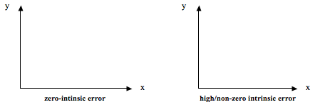

b) 4pts – Label the terms in the following formula where y(x; D) is the estimated mapping for x, learned from training set D; ED indicates the expectation aken over different data sets; and h(x) is the actual mapping that the learner is trying to estimate.

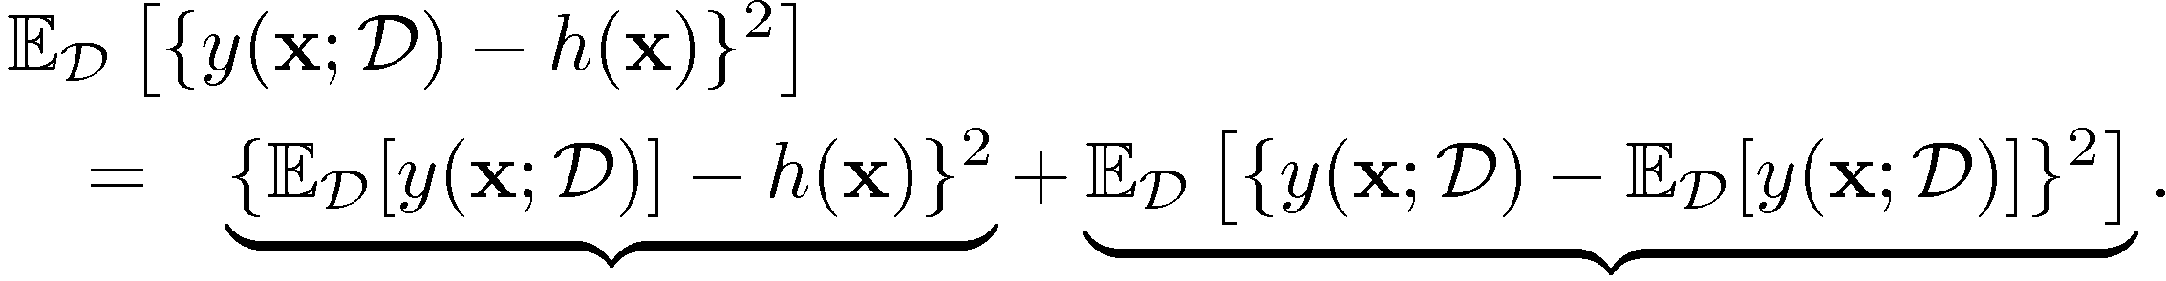

Answer: ……………………………………. ………………………………………………..

c) 4pt – Given the following data where each data point is given as a tuple (x,y=f(x)), what is the conditional expectation of y given x=4; i.e. E[y|x=4]?

(x1,y1) (x2 y2) . . . (x6 y6)

{ (2,50), (4,30), (4,30), (4,40), (6,4), (10,150) }

E[y|x=4] = ………….…….

d) 4pt –One can take two different approaches to classification: discriminative versus generative. Write the type of each of the following classifiers next to their name.

    - Decision Trees ………………………………………………………………..

    - Bayesian Classifier ……………………………………

    - Neural Networks ………………………………………………………………

    - SVM ……………………………………………………………………………

e) 4pt – Define likelihood considering a training data set X={x^{i}} and some distribution parameter θ?

L (Θ) = .................................. = ...................................

By definition Assuming N i.i.d data x^{i} ∈ X

f) 2pts – What is the Mahalanobis distance from a point p to a Gaussian distribution with mean μ and covariance matrix Σ? Give the formula and be careful to the details!

g) 3pts –Assume a random variable X is sampled from a one dimensional normal distribution with mean μ and standard deviation σ, answer the following accordingly. What is the probability that X takes on a value larger than μ?

- P( x >= μ ) = ...............................................................

